**Hello World RESTful Web Service**

**🔹 Project: spring-learn**

**🔹 Endpoint URL: http://localhost:8083/hello**

**🔹 Added Spring Boot Web Dependency**

The following dependency was added in the pom.xml to enable RESTful services:

<dependency>

<groupId>org.springframework.boot</groupId>

<artifactId>spring-boot-starter-web</artifactId>

</dependency>

**Spring Boot Configuration**

In application.properties, the following property was added to set the custom port:

server.port=8083

**🔹 Controller Class:**

package com.cognizant.spring_learn.controller;

import org.slf4j.Logger;

import org.slf4j.LoggerFactory;

import org.springframework.web.bind.annotation.GetMapping;

import org.springframework.web.bind.annotation.RestController;

@RestController

public class HelloController {

private static final Logger LOGGER = LoggerFactory.getLogger(HelloController.class);

@GetMapping("/hello")

public String sayHello() {

LOGGER.info("START - sayHello");

LOGGER.info("END - sayHello");

return "Hello World!!";

}

}

**🔹 Output**

* ✅ Accessed the URL: http://localhost:8083/hello
* ✅ Response in browser and Postman:

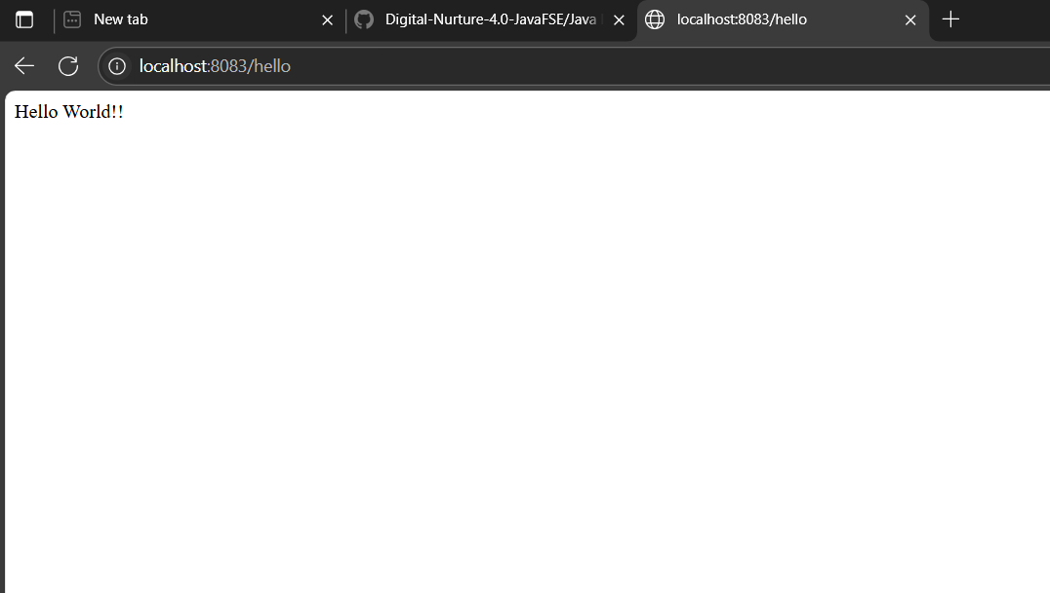

* ✅ Console Output:

